Exercise 18: Demo about State as a Snapshot

Objectives and Outcomes
In this example, we'll create a simple counter component that allows you to take a snapshot of the current count value and restore it later.

Exercises
Create a new React component called SnapshotDemo
import React, {useState} from 'react';

const SnapshotDemo = () => {
const [count, setCount] = useState(0);
const [snapshot, setSnapshot] = useState(null);

const handleIncrement = () => {
setCount(count + 1);
};

const handleSnapshot = () => {
setSnapshot(count);
};

const handleRestore = () => {
if (snapshot !== null) {
setCount(snapshot);
}
};

return (
<div>
<h1>State as a Snapshot Demo</h1>
<p>Count: {count}</p>
<button onClick={handleIncrement}>Increment</button>
<button onClick={handleSnapshot}>Take Snapshot</button>
<button onClick={handleRestore}>Restore Snapshot</button>
</div>
);
};

export default SnapshotDemo;
In this component, we use the useState hook to create two state variables: count and snapshot. The count state represents the current count value, while the snapshot state holds the snapshot of the count value.
We have three event handlers:
- handleIncrement: Increases the count value by 1 when the "Increment" button is clicked.
- handleSnapshot: Takes a snapshot of the current count value and stores it in the snapshot state when the "Take Snapshot" button is clicked.
- handleRestore: Restores the count value from the snapshot state when the "Restore Snapshot" button is clicked, but only if a snapshot is available.
The rendered JSX displays the count value, along with three buttons to increment the count, take a snapshot, and restore the snapshot.
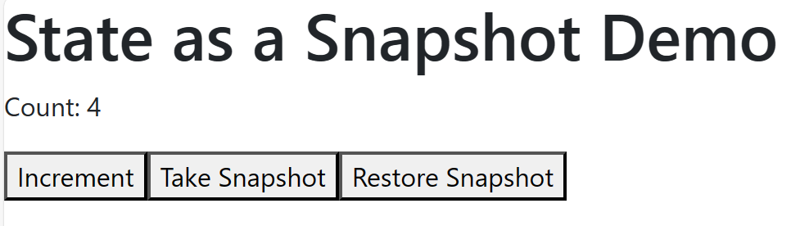
To use the SnapshotDemo component, render it in the root of your application:
import './App.css';
import React from 'react';
import './Component/SnapshotDemo';

function App() {
return (
<React.StrictMode>
<SnapshotDemo />
</React.StrictMode>
);
}

Conclusion
Using state as a snapshot allows you to save and restore specific states of your component. In this demo, we save the count value as a snapshot and restore it if a snapshot is available. This concept can be useful when you want to implement features like undo/redo functionality or save and restore user input in forms.

